**SOFTWARE ENGINEERING**

**(IT-314)**

**EVENT PLANNER APPLICATION**

Standards And Coding Convention

Version 1.0

**Team no: 14**

**Instructor: Prof. Asim Banerjee**

**Team Mentor: K Hemantha**

**Date: 26 March, 2016**

**Team Members**

|  |  |  |
| --- | --- | --- |
| **S.No** | **Name** | **ID** |
| 1. | Patel Yash | 201301008 |
| 2. | Patel Tej Naginbhai | 201301018 |
| 3. | Anavadiya Yash Kumar | 201301052 |
| 4. | Chauhan Dwimitra Dharmendra | 201301079 |
| 5. | Rahul Shashank Saranjame (Team Leader) | 201301101 |
| 6. | Fatnani Varun Kumarbhai | 201301152 |
| 7. | Nikita Jain | 201301155 |
| 8. | Karri Kiran Satish Reddy | 201301168 |
| 9. | Raman Kumar Douchaniya | 201301202 |

**Version History**

|  |  |  |
| --- | --- | --- |
| **Date** | **Version no.** | **Authors** |
| 26/03/2016 | 1.0 | Dwimitra Chauhan, Yash Patel, Tej Patel |

**Table of Contents**

1. Introduction.....................................................................................................4

1.1 Purpose..............................................................................................4

1.2 Scope.................................................................................................4

1.3 Coding Standard Documents.............................................................4

2. File and Module Guideline..............................................................................5

2.1 File Suffixes......................................................................................5

2.2 File Organisation..............................................................................5

2.3 Source Files……..............................................................................5

3. References…………………………………………………………………..8

1. **Introduction**
   1. **Purpose:**

The main purpose of this document is to create coding habit amongst project group members. By maintaining proper coding standards, the code written by different group members can be easily understood. Reviewing and maintaining of code becomes easier.

If we follow proper coding standard we can be benefited in the following ways:

1. Any programmer (group member) will be able to read and understand any part of the code.
2. Maintainability and reviewing becomes lot easier.
3. If a member is new to coding they can quickly become accustomed to following the existing standards.
4. A programmer new to the language is spared making the same mistakes over and over again, so reliability is increased.
5. It becomes lot easier to make corrections if any bugs are found.
   1. **Scope:**

This document describes general coding standards followed in writing any code. Coding convention of all the languages used are to be described in this document. Also proper guidelines are to be followed for each language.

* 1. **Coding standard documents:**

Each project has a particular set of coding standards. Coding standards consist of following parts:

* General coding standards must be mention in this document.
* Specifying coding standards for each languages used.
* Language standards won’t affect general coding standards. It will rather help.
* Project coding standards are based on coding standards in this document and coding standard of languages.
* The project standard should be such that there is no conflict with language standards and general standards.
* If there is any kind of conflict then project standards are to be considered.

1. **File and Module Guideline**
   1. **File Suffixes**

We will use following suffixes:

|  |  |
| --- | --- |
| **File Type** | **Suffix** |
| PHP File | .php |
| HTML File | .html |
| CSS File | .css |
| Sql File | .sql |

* 1. **File Organization:**

In the file, if there are sections then each sections should be separated by blank lines or comments about than section.

* 1. **Source files:**

We have followed standard coding conventions of WordPress

* + 1. **PHP Source files:**

1). **Quotes:** Using single or double quotes when needed. For eg. We use double quotes for string and single quotes for variable.

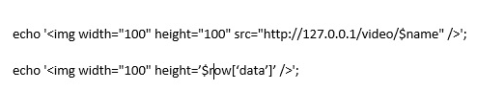

2). **Indentation:** indentation is done by using ‘tabs’ instead of using spaces. It will properly format the structure.

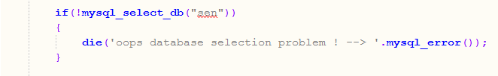

3). **Trailing spaces:** there should be no space at end of each line of code.

4). **Naming Conventions:**

Using lower case letters for functions and variables.



File name should be separated using underscores.



File containing template tags in WordPress should have (template-“filename”.php).



* + 1. **HTML Source Files:**

1). **Self-closing Elements:**

All tags must be properly closed. For those tags that are self-closing, the forward slash should have exactly one space preceding it. W3C standards specifies that single space should precede the self-closing slash.

2). **Attributes and Tags:**

All tags and attributes are in lowercase. As purpose of text is to be interpreted by machines therefore attribute value is lowercase. Data needs to be human readable and also proper title capitalization should be followed.



3). **Quotes:**

W3C standard for HTML5 implies that all attributes must have a value, and must use double or single quotes. Following are example of quotes:



4). **Indentation:**

Same as PHP, using tabs instead of spaces. It will ensure proper structure. When PHP and HTML are mixed together, indent PHP blocks to match HTML code.

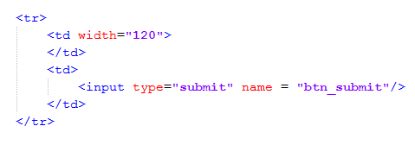

5). **Naming Convention:**

Abbreviate words when needed. i.e. Button – btn. Separating words by using underscores or hyphens. For mentioning action initially letter must be in uppercase. As shown in below.



* + 1. **JavaScript Source Files:**

1). **Braces:**

For multiline blocks, braces should be mention in separate line. As shown here:

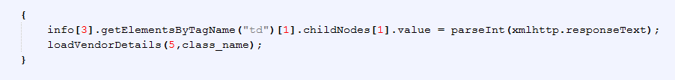

2). **Whitespace:**

We used underscores for mentioning names of functions and variables.

3). **File Name:**

We have implemented JavaScript in PHP files. So, we do not have any file with extension .js. Extension of PHP file is .php.

4). **var keyword:**

Var statement is used to declare any local variable necessary. Each variable is separated by a single comma. The variable or variables defined by var statement should be mention on separate line.

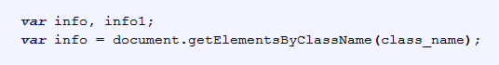

5). **Loops:**

There are many loops used in JavaScript. The loop construction of JavaScript is similar to PHP. We have mainly used while loop. There are no convention of using any particular loop. But for different loops there are some standards used.

**2.3.4. CSS Source Files:**

For CSS files we have followed standards and convention used in WordPress.

**3. References**

Standards and Conventions v1.0, Team 7, IT314 Software Engineering, Winter 2012-13, DA-IICT.